1. Distinguish between man and whatis commands? Justify with proper example.
Ans.
man | whatis
Displays the full manual page of a command with detailed explanation. | Shows a one-line short description of a command.
Useful for understanding all options, usage, syntax, and examples. | Useful for quickly identifying the purpose of a command.
Example: man ls opens a full manual. | Example: whatis ls shows: ls (1) – list directory contents.

2. Use the tee command to save the output of ls -l into a file while also displaying it. (CO4)
Ans. 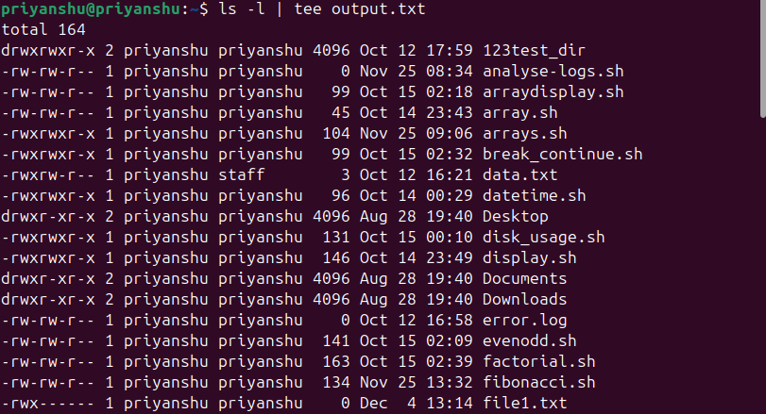

3. Explain with an example how the tee command can be used in logging. (CO4)
Ans. The tee command is useful in logging because it allows you to save the output of a command to a log file while still displaying it on the screen. This is especially helpful when monitoring processes in real time. For example, running ping google.com | tee ping.log will show the live ping results on the terminal and simultaneously store them in the file ping.log. This way, you can watch the output as it happens and also keep a permanent log for later analysis.

4. List the steps involved in installing Ubuntu 25.04 LTS on Oracle VirtualBox. (CO2)
Ans. Download Ubuntu ISO File
Visit the Ubuntu website and download the Ubuntu 25.04 LTS ISO image.
Install Oracle VirtualBox
Download and install VirtualBox on your computer.
Create a New Virtual Machine
- Open VirtualBox → Click New
- Enter the name: Ubuntu 25.04 LTS
- Select Type: Linux
- Select Version: Ubuntu (64-bit)
Allocate Memory (RAM)
- Choose at least 2 GB (2048 MB) or more (recommended: 4 GB+).
Create Virtual Hard Disk
- Select Create a virtual hard disk now
- Choose VDI (VirtualBox Disk Image)
- Select Dynamically allocated
- Set size to 20 GB or more
Attach the Ubuntu ISO File
- Go to Settings → Storage
- Under Controller: IDE, click the empty disk icon
- Click Choose a disk file
- Select the downloaded Ubuntu 25.04 ISO
Configure Boot Settings
- Make sure the ISO is set as the optical startup disk.
Start the Virtual Machine
Click Start to boot from the ISO.
Begin Ubuntu Installation
- Choose Install Ubuntu
- Select language and keyboard layout
- Choose installation type (Normal/Minimal)
- Select Erase disk and install Ubuntu (only affects the VM)
Set User Information
Enter your name, username, password, and computer name.
Wait for Installation to Complete
The setup will copy files and finish installation.
Restart the Virtual Machine
After installation, restart the VM and remove the ISO when asked.
Ubuntu Desktop Loads
You will now see the Ubuntu 25.04 desktop environment inside VirtualBox.

5. During Ubuntu OS installation, you face a Kernel Panic Error. How would you troubleshoot it? (CO3)
Ans. A Kernel Panic Error during Ubuntu installation usually occurs due to hardware misconfiguration, corrupt ISO, or incompatible VirtualBox settings. To troubleshoot it, first ensure that the Ubuntu ISO file is not corrupted by checking its checksum or downloading it again. Then, verify that VirtualBox settings are properly configured: enable VT-x/AMD-V in your system BIOS, allocate enough RAM (at least 2–4 GB), and assign at least 2 CPU cores if possible. Also disable settings like I/O APIC, Nested Paging, or Hyper-V if they cause instability. Updating VirtualBox to the latest version can also fix kernel panic issues. If the error persists, try changing the graphics controller to VMSVGA and setting video memory to 128 MB, or switch from EFI boot to Legacy boot. These steps usually resolve the kernel panic and allow the installation to proceed smoothly.

6. Write the command to display the system’s hostname? How to change hostname using sysctl command? (CO1)
Ans.
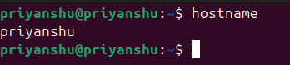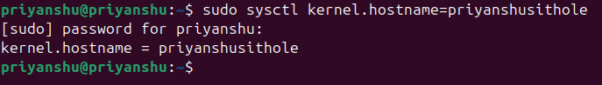

7. Which command is used to show the calendar of the year 1984 with August month? (CO1)
Ans.
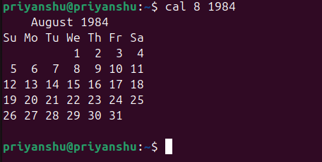

8. Write a command to display system uptime and logged-in users together. (CO3)
Ans.
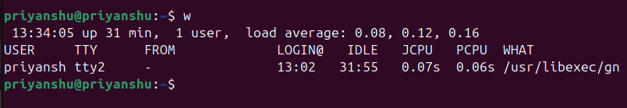

9. Use the find command to list all “.c” files in /home/user. (CO1)
Ans.
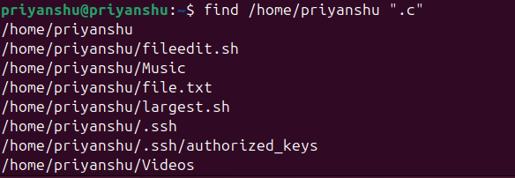

10. How do you change file permissions to allow only the owner to read and write? (CO1)
Ans.
